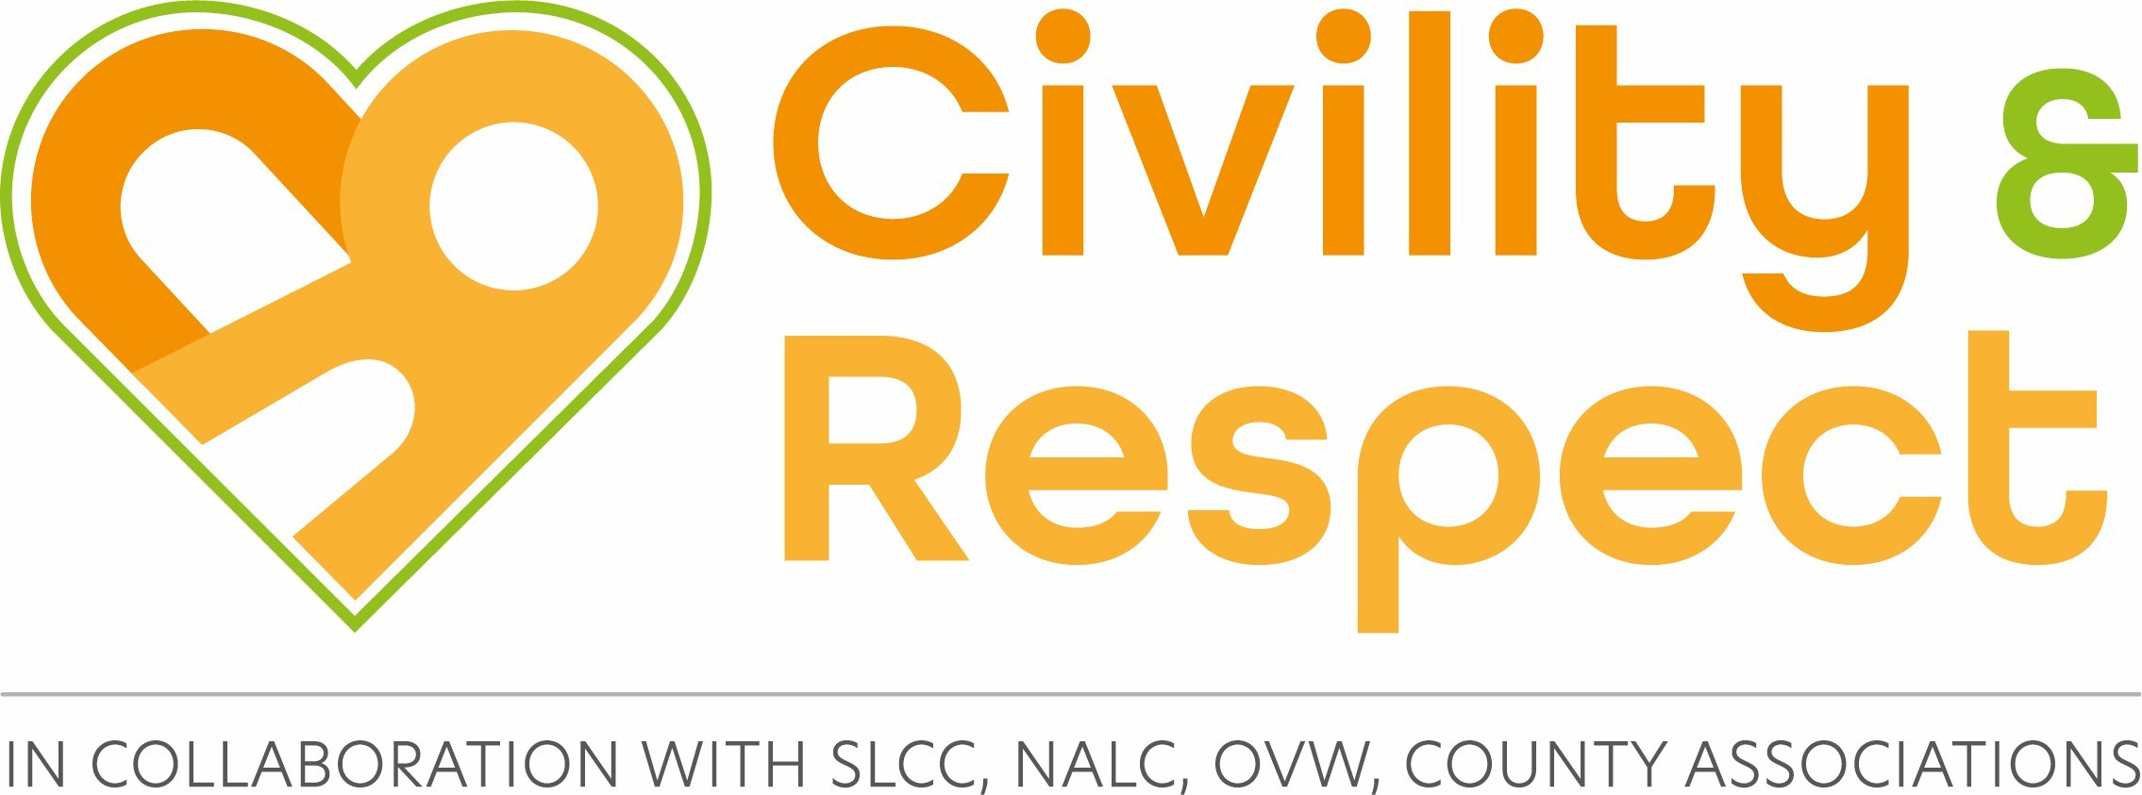

Civility and Respect Pledge
Civility means politeness and courtesy in behaviour, speech, and in the written word. Examples of ways in which you can show respect are by listening and paying attention to others, having consideration for other people’s feelings, following protocols and rules, showing appreciation and thanks, and being kind. The National Association of Local Councils (NALC), the Society of Local Council Clerks (SLCC), and One Voice Wales (OVW) believe now is the time to prioritise civility and respect and start a culture change in the local council sector. By signing the Civility and Respect Pledge, our council demonstrates its commitment to treating councillors, clerks, employees, members of the public, representatives of partner organisations, and volunteers with civility and respect in their roles.
Signing up is a straightforward and uncomplicated process, which only requires councils to register with One Voice
Wales and agree to the following statements:

Date of Council Meeting ..................................... Council Name ……………….……… Signature .................................................

Statement | Tick
Our council has agreed that it will treat all councillors, clerks, employees, members of the public, representatives of partner organisations, and volunteers with civility and respect in their role.
Our council has put in place a training programme for councillors and staff.

Our council has provided councillors with the Code of Conduct.

Our council has good governance arrangements in place including staff contracts and a dignity at work policy.

Our council will commit to seeking professional help in the early stages should civility and respect issues arise.

Our council will commit to calling out bullying and harassment if and when it happens.

Our council will continue to learn from best practice in the sector and aspire to being a role model.

Our council supports One Voice Wales in relation to its work with the Welsh Government to improve the effectiveness of the ethical framework in Wales.

