Community & Town Councils
Biodiversity Action Plan 2026-2028
Environment (Wales) Act 2016 Part 1 – Section 6 The Biodiversity and Resilience of Ecosystems Duty
Name of Community & Town Council:
Council type (Group 1, 2 or 3):
Introduction and Context

NRAP  Aim | Actions  planned | Time  scale | Monitored  by:
1. Protect, restore and effectively manage ecosystems to build their resilience.

2. Safeguard species and improve their management.

3. Tackle key pressures on species, habitats and ecosystems.

4. Establish effective governance and capacity to deliver.

5. Embed biodiversity through engagement and awareness raising to support effective decision making at every level.

6. Improve our evidence and monitoring.

Annual review of the Biodiversity Action Plan
Date reviewed: | /2026 |  | /2027 |  | /2028
What has worked well?
What have the barriers been?
What will you change?
Review approved: |  | /2026 |  | /2027 |  | /2028
Next review: |  | /2027 |  | /2028

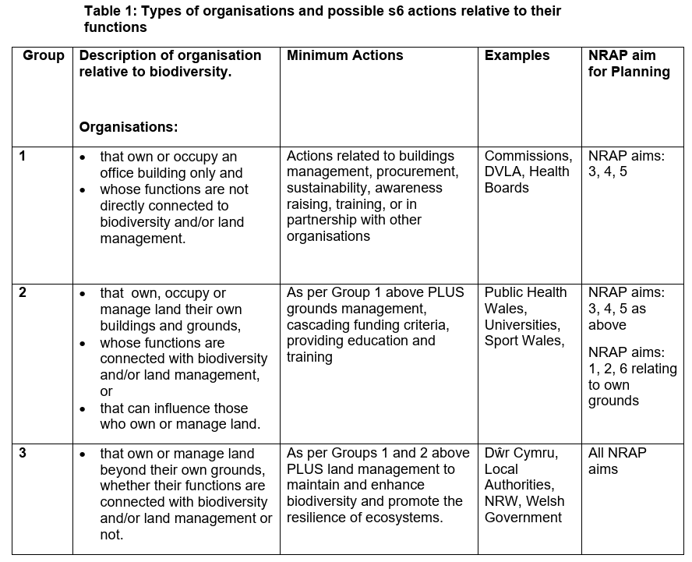
NRAP Aim 3: Protect, restore and effectively manage ecosystems to build their resilience.
NRAP Aim 4: Establish effective governance and capacity to deliver.
NRAP Aim 5: Embed biodiversity through engagement and awareness raising to support effective decision making at every level.

NRAP Aim 1: Protect, restore and effectively manage ecosystems to build their resilience.
NRAP Aim 2: Safeguard species and improve their management.
NRAP Aim 6: Improve our evidence and monitoring.

Back

