Tips for Keeping Warm this Winter  • If you’re sitting down, wrap up with a shawl or blanket. Air is cooler at ground level – so you could even pop your feet up on something.  • If you struggle to stay warm in bed, try wearing some warmer layers. If it’s particularly cold, thermal underwear and bed socks are a good idea – even a hat can really help you keep warm.  • Use a hot water bottle, heat bag or an electric blanket to warm the bed – but never use a hot water bottle and an electric blanket together.  Check that everything’s working  • It’s a good idea to get your heating system serviced every year in the run-up to winter to make sure it is running safely and efficiently.  • Water pipes can freeze and burst when it’s cold, so it’s important to know where your main stopcock is – and to check that it’s easy to turn in case you need to turn the water off.  • Install a carbon monoxide alarm in each room with a burning appliance and check fire alarms are working |  |  | Tips for getting prepared this Winter    Keep some extra food in the cupboard or freezer in case you can’t get to the shops.    Keep a mixture of salt and sand handy to put on steps and paths when it is icy – this can help you avoid a fall.      If you are worried about walking your dog in icy weather, see if family, friends or a neighbour can help. There may be local volunteers in your area.  Keep simple cold, flu and sore throat remedies at home.      Order repeat prescriptions in plenty of time, particularly if the weather might stop you getting out. Ask if your local pharmacy offers a delivery service.  Follow simple hygiene measures to avoid germs and keep your distance from anyone with symptoms of a bug or illness.  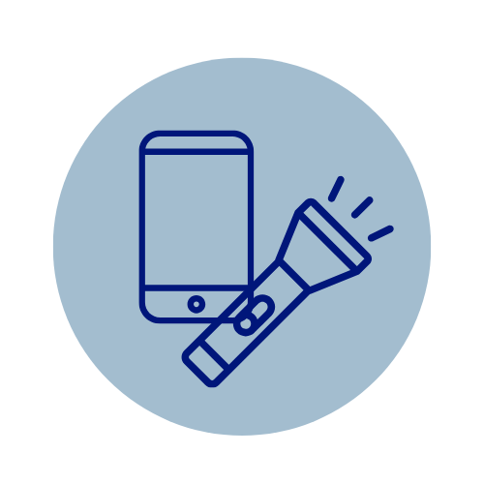  Keep a torch handy in case there is a power cut. Keep things like mobile phone, radio or laptop charged. |  |  |   Winter Wellbeing  Information Advice & Support  
Stay Connected this Winter  Check in on neighbours, friends, or relatives – a friendly call or visit can make a big difference.  Join local coffee mornings, warm hubs, or community events – you’ll find warmth and company.  Follow your community Facebook page or website for updates on local support and weather alerts.  Insert a QR code for your website/place to find up to date information    Insert your logo/contact information  Print back to back to produce a 3- fold flyer |  |  |  | Local Support  (type information for your area here)  Eg: Emergency Support (community resilience plan)  Local Authority Details  Community Connectors  Hospital/Minor Injuries  Age Cymru  Citizens Advice  Mental Health  Community Transport  Food Support (foodbanks, lunch clubs, meals on wheels)  Warm Hubs  Local Cost of Living Support  Energy Advice  Groups & Organisations  Events Any other good neighbour schemes or support you offer
  Useful Numbers
  It’s a good idea to jot down some important contact numbers that may come in handy over the Winter:
  Gas Supplier:
  Electricity Supplier:
  Water Supplier:
  Plumber:
  Electrician:
  GP Practice:
  Pharmacy:
  Other:
  Other:
  To Do:
  Register with National Grid Priority Services Register to get extra help and support in a power cut. Go online or Tel: 0800 032 8301.
  