***Community & Town Councils***

**Biodiversity Action Plan**

***Environment (Wales) Act 2016 Part 1 – Section 6 The Biodiversity and Resilience of Ecosystems Duty***

|  |  |  |
| --- | --- | --- |
| **Name of Community & Town Council:** |  | |
| **Council type** **(Group 1, 2 or 3 for NRAP Objectives):** | |  |
| **Introduction** **and Context** | | |
| *Provide a short description of the Council, its functions and context in relation to*   * *how it could help biodiversity (through functions with regard to land management, grant funding, education activities, for e.g.)* * *spatial scale and place (e.g. how much land does it cover, population, precept?)* * *public service delivery (e.g. is it subject to the Well-being of Future Generations (WFG) Act?)* | | |
|  | | |

|  |  |  |  |  |
| --- | --- | --- | --- | --- |
| **NRAP**  **Objectiv**e | **Biodiversity objectives** | **Action planned** | **Time scale** | **Monitored by:** |
| **1** | **-embed biodiversity into decision making & procurement** |  |  |  |
| **-raise awareness of biodiversity & its importance** |  |  |  |
| **2** | **-safeguard principal species and habitats** |  |  |  |
| **3** | **-restore & create habitats and resilient ecological networks** |  |  |  |
| **4** | **-tackle negative factors: for e.g. reduce pollution, use nature based solutions, address invasive species** |  |  |  |
| **5** | **-use, improve, and share evidence** |  |  |  |
| **6** | **-support capacity and/or other organisations** |  |  |  |

|  |  |  |  |  |
| --- | --- | --- | --- | --- |
|  | | |  |  |
| **Annual review of the Biodiversity Action Plan** | | | **Date reviewed:** |  |
| **What has worked well?** |  | | | |
| **What have the barriers been?** |  | | | |
| **What will you change?** |  | | | |
|  | |  | | |
| **Next review due:** |  |  | | |
| **Approved by Council on:** |  |  | | |

***Cynghorau Cymuned a Thref***

**Cynllun Gweithredu Bioamrywiaeth**

***Deddf yr Amgylchedd (Cymru) 2016 Rhan 1 – Adran 6 Y Ddyletswydd Bioamrywiaeth a Chydnerthedd Ecosystemau***

|  |  |  |
| --- | --- | --- |
| **Enw’r Cyngor Tref neu Gymuned:** |  | |
| **Math o gyngor** **(Grŵp 1,2, neu 3 ar gyfer amcan NRAP)** | |  |
| **Cyflwyniad a'r Cyd-destun** | | |
| *Disgrifiad byr o'r Cyngor, ei swyddogaethau a'r cyd-destun o ran:*   * *sut y gallai helpu bioamrywiaeth (trwy ei swyddogaethau rheoli tir, cyllid grant, gweithgareddau addysgol e.e.).* * *graddfa ofodol a lle (e.e. faint o dir mae'n ei gynnwys, poblogaeth, praesept?).* * *cyflawni gwasanaethau i'r cyhoedd (e.e. a yw gofynion Deddf Llesiant Cenedlaethau'r Dyfodol yn berthnasol iddo?).* | | |

|  |  |  |  |  |
| --- | --- | --- | --- | --- |
| **Amcan**  **NRAP** | **Amcan Bioamrywiaeth** | **Camau arfaethedig** | **Graddfa amser** | **Wedi eu monitro gan:** |
| **1** | **-cynnwys bioamrywiaeth o fewn llunio penderfyniadau a chaffael** |  |  |  |
| **-codi ymwybyddiaeth o fioamrywiaeth a'i bwysigrwydd** |  |  |  |
| **2** | **-diogelu prif rywogaethau a chynefinoedd** |  |  |  |
| **3** | **-adfer & chreu cynefinoedd a rhwydweithiau ecolegol cydnerth** |  |  |  |
| **4** | **-mynd i'r afael ag elfennau negyddol: lleihau llygredd e.e. defnyddio atebion yn seiliedig ar natur, mynd i'r afael â rhywogaethau goresgynnol** |  |  |  |
| **5** | **-defnyddio gwella a rhannu tystiolaeth** |  |  |  |
| **6** | **-cefnogi capasiti a/neu sefydliadau eraill** |  |  |  |

|  |  |  |  |  |
| --- | --- | --- | --- | --- |
|  | | | | |
| **Adolygiad blynyddol o’r Cynllun Gweithredu Bioamrywiaeth** | | | **Dyddiad yr adolygiad:** |  |
| **Beth sydd wedi gweithio'n dda?** |  | | | |
| **Beth fu'r rhwystrau?** |  | | | |
| **Beth fyddwch yn ei newid?** |  | | | |
|  | |  | | |
| **Dyddiad yr adolygiad nesaf:** |  |  | | |
| **Cymeradwywyd gan y Cyngor ar:** |  |  | | |

Back

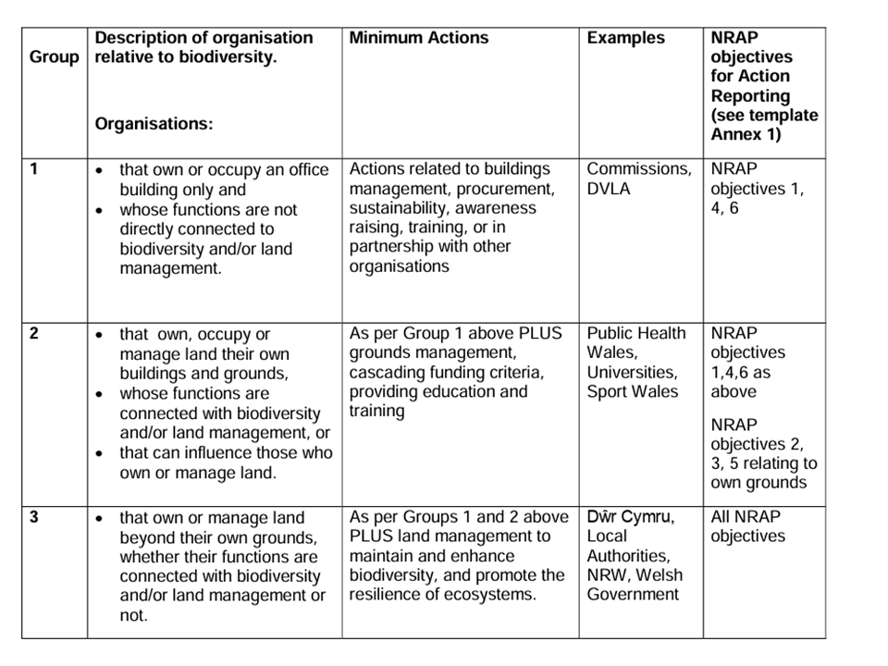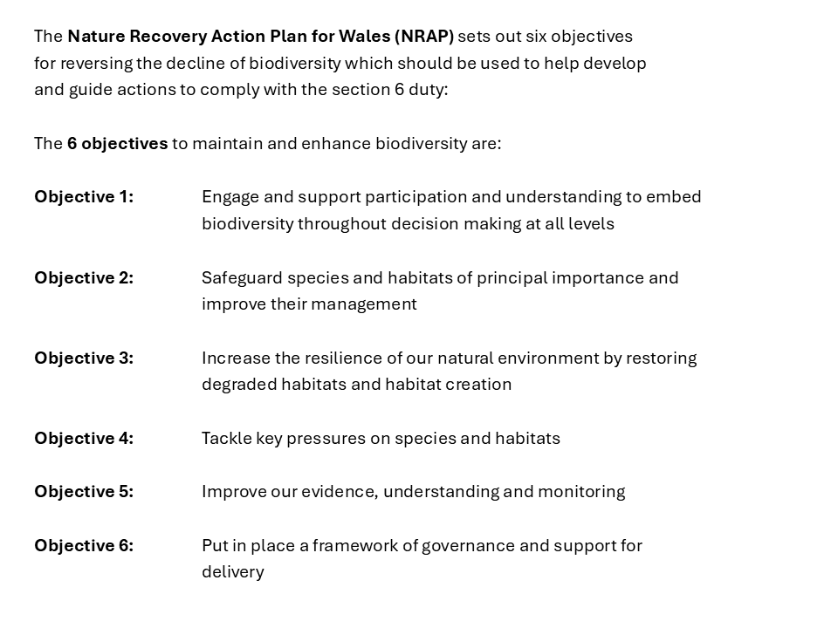

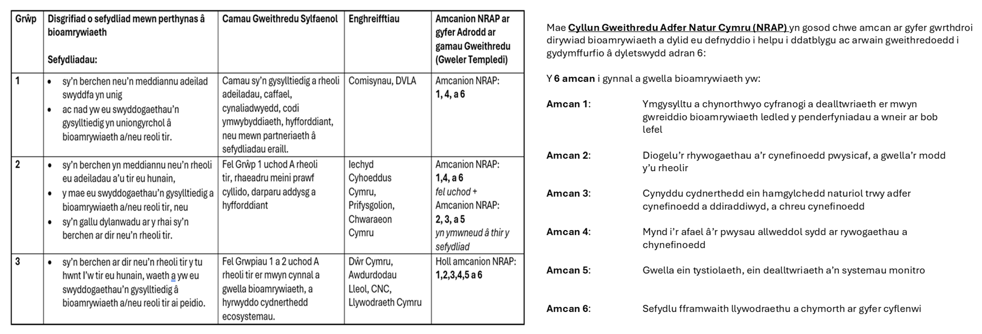

Nôl